-Name:- Seif Eldien Adel Sapry Abd Elatief Ibraheem

Group:- 3-

Section:- 17-

B.N:- 7-

-Topic:- computer architecture

Github-link:- <https://github.com/seif265/html.project-repsitory>

Application brief:-

I used (Notepad++)application to make my project because I found easy of use it and it was simple to deal with it

Notepad++ is a free (as in “free speech” and also as in “free beer”) source code editor and Notepad replacement that supports several languages. Running in the MS Windows environment, its use is governed by GNU General Public License.

Based on the powerful editing component Scintilla, Notepad++ is written in C++ and uses pure Win32 API and STL which ensures a higher execution speed and smaller program size. By optimizing as many routines as possible without losing user friendliness, Notepad++ is trying to reduce the world carbon dioxide emissions. When using less CPU power, the PC can throttle down and reduce power consumption, resulting in a greener environment

Screen shouts:-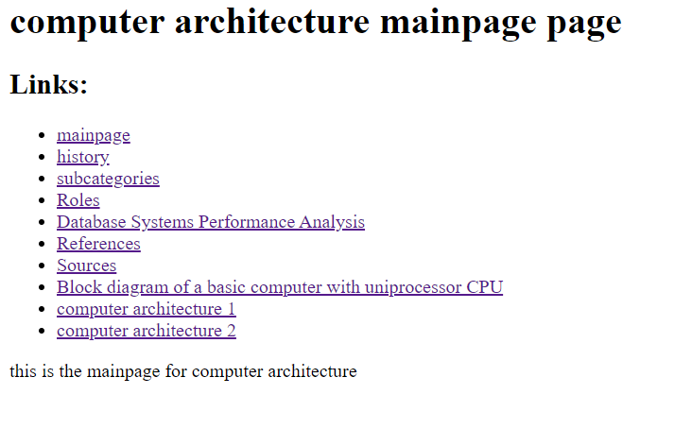

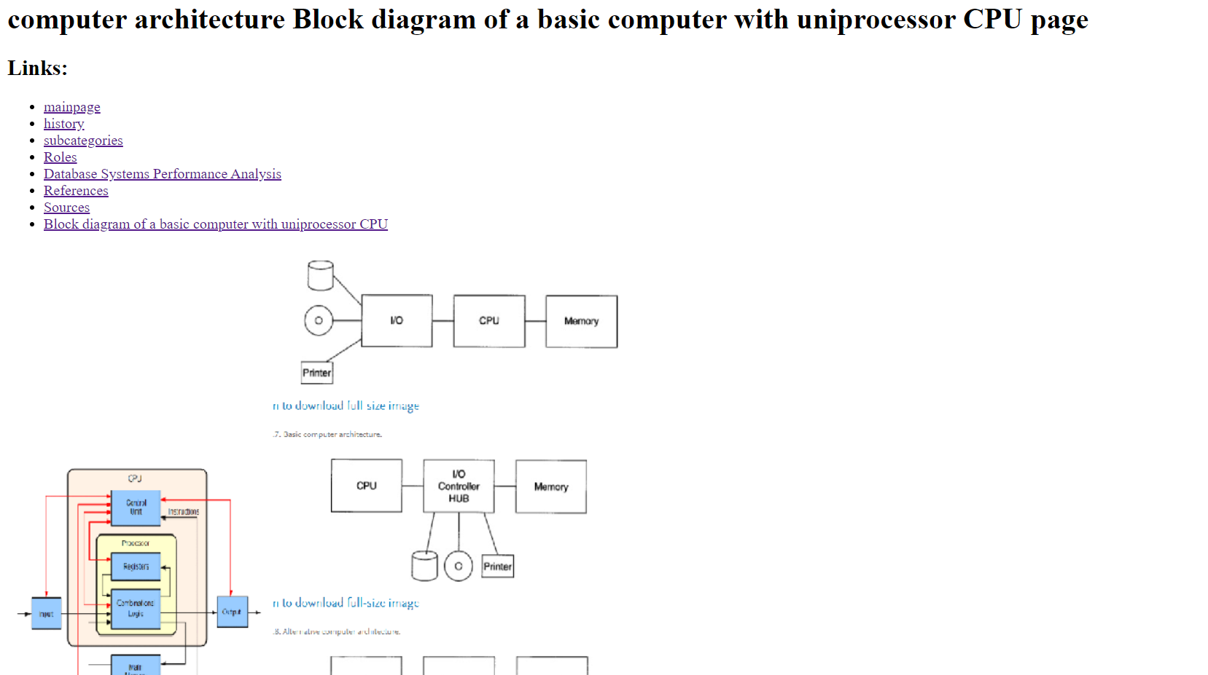



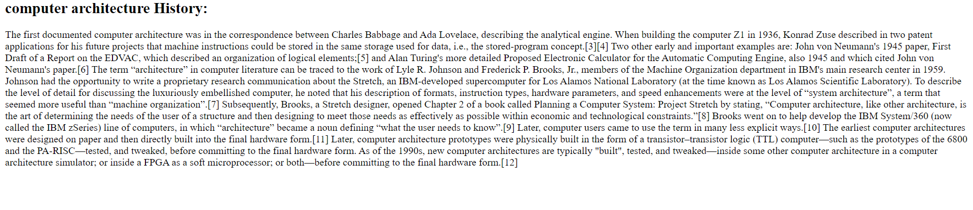

Source code:-

